Fast**National University of Computer & Emerging Sciences, Karachi  
Fall-2018 CS-Department**

**Lab Mid**

|  |  |  |
| --- | --- | --- |
| **Course Code: CL205** | **Course Name: Operating Systems Lab** | |
| **Instructor Name: Sumaiyah Zahid** | | |
| **Student Roll No:** | | **Section:** |

***"Be willing to take a chance, because you never know how perfect something could turn out to be."  
BEST OF LUCK!***

Instructions

* Rules are made to break them. So, invent yours and I’ll break.

**Time**: 60 minutes. **Max Marks:** 40 points

1. **Marks)**

1. Display lines from planets.txt which has the term ‘earth’ in the line and put the output to the file ‘search_result.txt’

____________________________________________________________________________________________________________________________________________________________

2. Copy the contents of the file ‘datum.txt’ to a file datum_copied.txt

____________________________________________________________________________________________________________________________________________________________

3. Create a read-only file in your home directory.

____________________________________________________________________________________________________________________________________________________________

4. List the files in the directory "/etc" that have “network" in their strings.

____________________________________________________________________________________________________________________________________________________________

5. Copy all files in the current directory whose names end in ".c" or ".h" into the subdirectory "Programs".

____________________________________________________________________________________________________________________________________________________________

Differentiate between “sh” and “bash”. **(2.5 marks)**

Write a Bash program that prints the number of arguments provided to that program multiplied by the first argument provided to the program.  **(3 marks)**

Write a Bash script that takes two arguments. If both arguments are numbers, print their sum, otherwise just print both arguments. **(4.5 marks)**

Write a script to find out String is palindrome or not. **(5 marks)**

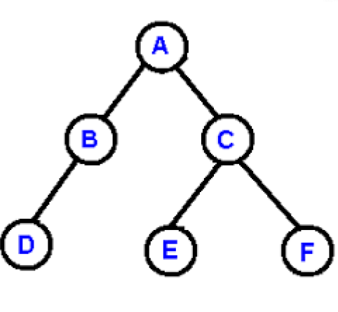Write a c program for this process tree.

Each node will print its name and PID but by not using printf().

**(10 marks)**

Write System calls for Shared Memory other than shmget **(10 marks)**



System call for named pipe is _____________________.

System call for unnamed pipe is ____________________.

System call for generating key is _____________________.

Explain functions and their arguments:

shmid = shmget(key, MAXSIZE, IPC_CREAT | 0666)

msgsnd(msgid,&msg,sizeof(msg),0)

write(fd,buffer,sizeof(buffer));

**Bonus Question:**

Write anything which proves me you are a Linux User. Bonus marks depends on your creativity.